**Experiment-4 Study of Dynamic Routing**

ECP316 (Communication Networks)

**Aim:** Understanding and implementing dynamic routing for simulating package transfer between different networks.

**Tools Used:** Cisco Packet Tracer

**Theory:**

Dynamic routing is a method used in networking where routers automatically adjust their routing tables based on current network conditions. Unlike static routing, where routes are manually configured, dynamic routing uses protocols to discover and maintain routes. Popular dynamic routing protocols include OSPF (Open Shortest Path First), EIGRP (Enhanced Interior Gateway Routing Protocol), and BGP (Border Gateway Protocol).

### **Advantages of Dynamic Routing**

* **Automatic Updates:** Routes are automatically adjusted based on network changes, reducing the need for manual intervention.
* **Scalability:** Easily handles large and complex networks, as routing tables are dynamically maintained.
* **Fault Tolerance:** Automatically reroutes traffic in case of link failures or network congestion, improving network reliability.
* **Optimized Path Selection:** Chooses the most efficient route for data packets based on current network conditions.

### **Disadvantages of Dynamic Routing**

* **Complexity:** Requires more complex configuration and management compared to static routing.
* **Resource Intensive:** Consumes more CPU and memory resources as routers need to constantly update and maintain routing tables.
* **Convergence Time:** Dynamic routing protocols can take time to converge (i.e., reach a stable state), which may lead to temporary routing issues during network changes.
* **Security Risks:** More vulnerable to attacks if not properly secured, as the dynamic exchange of routing information can be exploited.

### **Applications**

* **Large Enterprise Networks:** Used in organizations with large, complex network infrastructures where manual routing updates would be impractical.
* **Service Providers:** Internet Service Providers (ISPs) use dynamic routing to manage traffic across multiple network paths.
* **WANs (Wide Area Networks):** Suitable for WANs where network topology changes frequently, and maintaining manual routes is challenging.
* **Data Centers:** Helps in managing traffic dynamically within large data centers with multiple redundant paths.

**Procedure:**

1. Open Cisco Packet Tracer application on computer.
2. Use PCs and give them IP addresses to the PCs and then configure the RIPs only to send the messages the Routers will automatically get connected.
3. Use PT Switch and Router only as they’re already defined according to our use.
4. Use RJ45 Cables to connect the PCs and switches as according to the topology diagram. We can check the connections using ping in the command prompt of each PC.
5. Try sending mail from one PC to another and start simulation and observe.
6. Try Sending on different paths like 1st router sub-PC to 2nd router sub-PC etc..

**RIPs of each Router:**

**Router 1**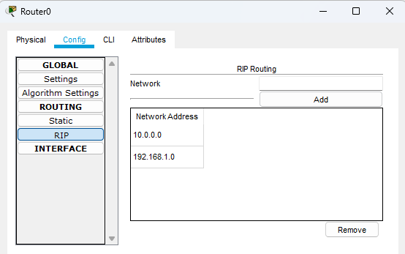

**Router 2**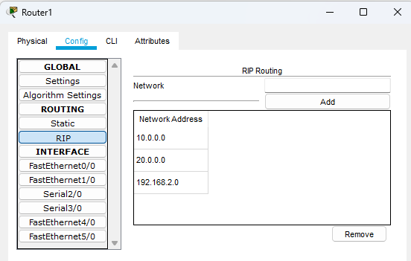

**Router 3**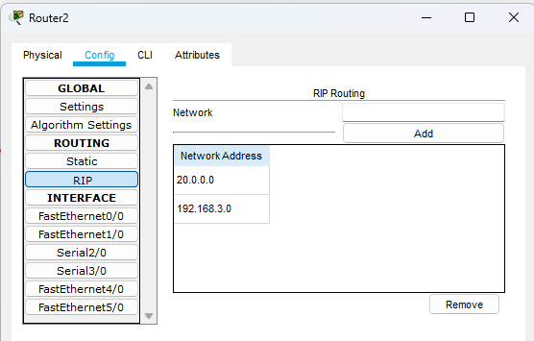

**Connections:**

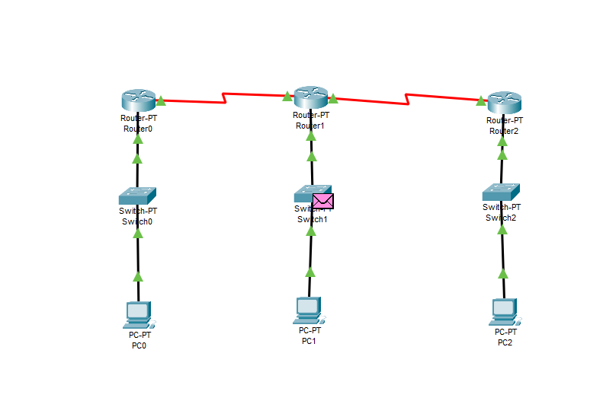

**Testing on Routes (Simulation):**

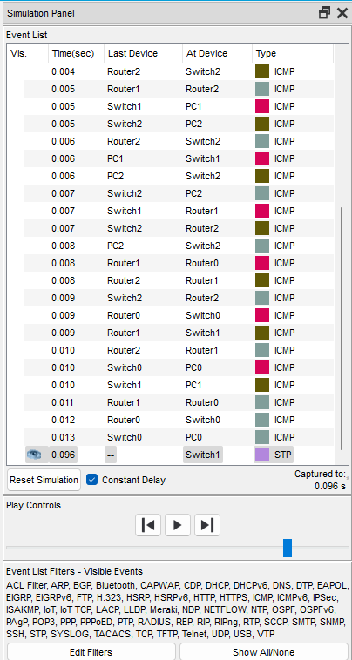

**Success:**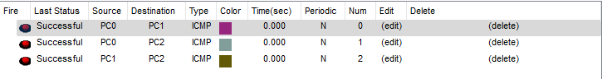

**Result:**

In this analysis, we’ve tried dynamic routing for 3 routers and their sets of PCs and made sure that each PC has a connection with every other PCs via router (i.e. routing).

**Conclusion:**

1. **Adaptive Routing Approach:** Dynamic routing automatically adjusts the routing paths based on the current network conditions.
2. **Ideal for Larger, Fluctuating Networks:** It is particularly beneficial for larger networks with changing traffic patterns.
3. **Flexibility:** Provides flexible routing paths that can adapt to network changes, such as link failures or congestion.
4. **Higher Complexity:** Requires the implementation of routing protocols and algorithms, which can add complexity and overhead to the network.
5. **Automated Configuration:** Relies on automated algorithms for route discovery and maintenance, reducing manual intervention.
6. **Versatile Applications:** Best suited for scenarios where the network topology is dynamic, such as in enterprise networks, data centers, and large-scale internet service provider (ISP) networks.